**Need for Version Control System and Continuous Integration**

* Multiple Developers working on to build an application.
* Each Developer works on his local system, how can we integrate the code from multiple developers

Big Bang Integration: Consider the movie booking

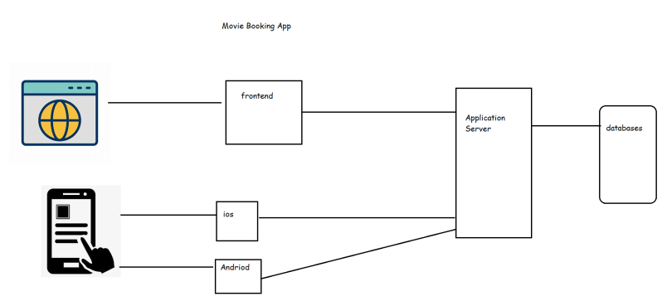

Each team is working on their own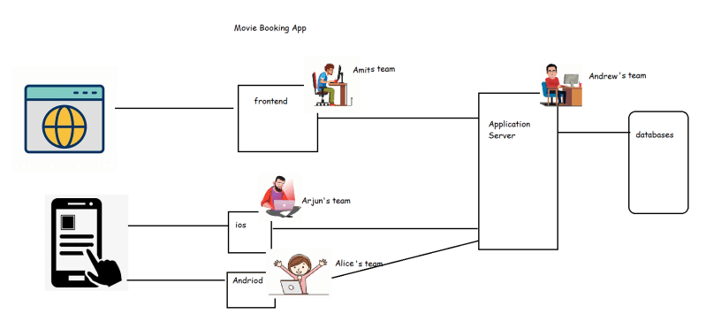

Just before 15 days to release all the teams try to make their applications interact with each other by integrating the code.

It was observed in many cases that the team will observe lot of failures and to meet the release date, they make temporary fixes which will ruin the application quality

To make the application development process simpler continuous integration was introduced where all the code by different teams will be integrated every time (hourly, daily) then create an application package

Options for sharing code

* + email
  + shared folder

Merging the code has to be done by all the developers manually.

We need the following options

* + versions
  + merge the changes
  + revert the changes

Version Control is a system that records changes to a file or group of files and directories over time and it allows multiple developers to integrate their work.

* Some popular Version Control Systems
  + Subversion (SVN)
  + IBM Clear Case
  + Team Foundation Version Control
  + Perforce
  + Git
* Version Control Architecture Evolution.
  + Client Server to Distributed Systems

**Relevance of Version Control for DevOps Engineer**

* As a DevOps Engineer, we will work to develop scripts or configurations (Terraform, Chef, Ansible, Docker, k8s) and we need to integrate this activity with the team, so we need to have a good working knowledge on Version Control System.
* In some organizations, DevOps Engineers are expected to ensure all the team members are using version control system efficiently.
* The CI/CD Pipeline starts from VCS, so we need to understand the VCS to trigger the builds & continue with pipeline.